Q2. Explain StringBuffer **class insert method** in java programming?

Ans:

The Insert method inserts the given String with the specified position,

Syntax:

StringBuffer insert(int position,String object);

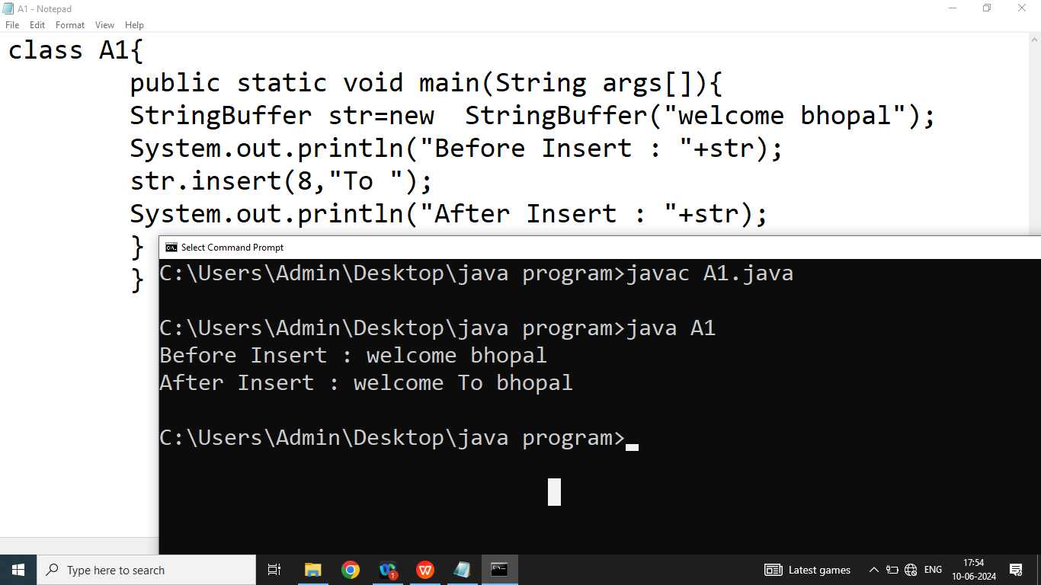

Q2. Explain StringBuffer class **replace()** method in java programming?

Ans:

The replace method replaces the given String from the specified String(from index to endIndex).

Syntax:

StringBuffer replace(int startindex, int endindex, String);

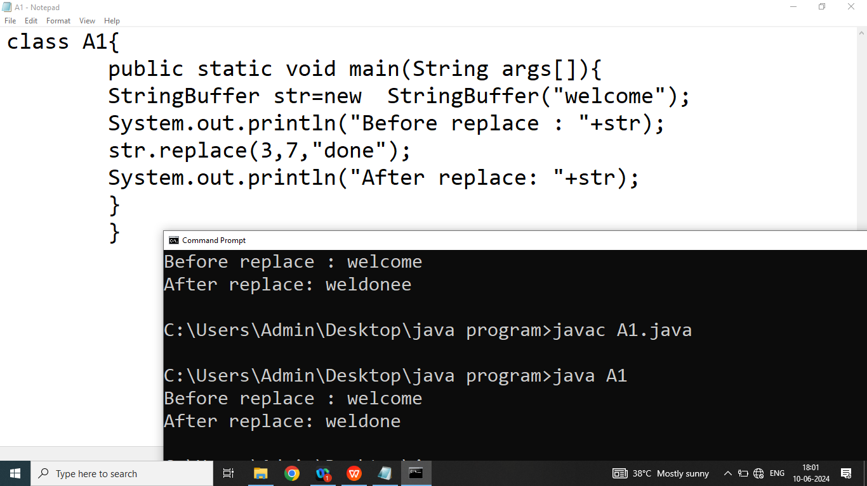

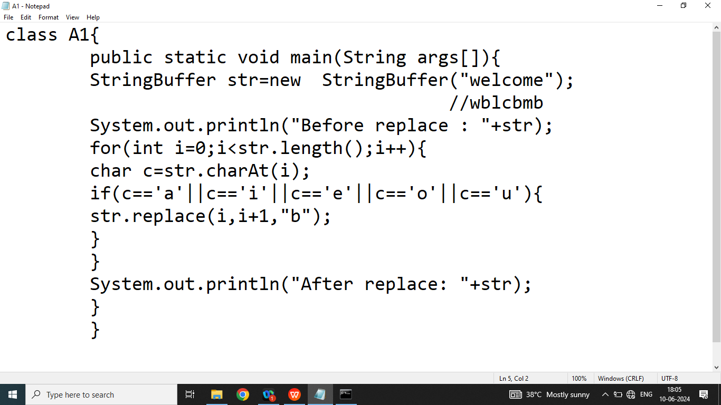

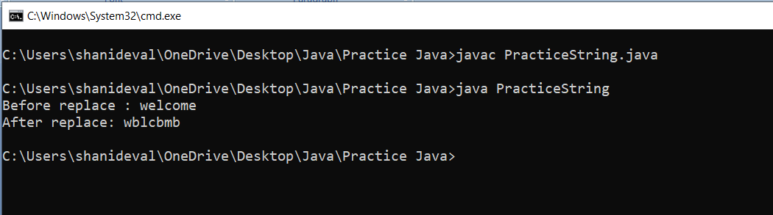

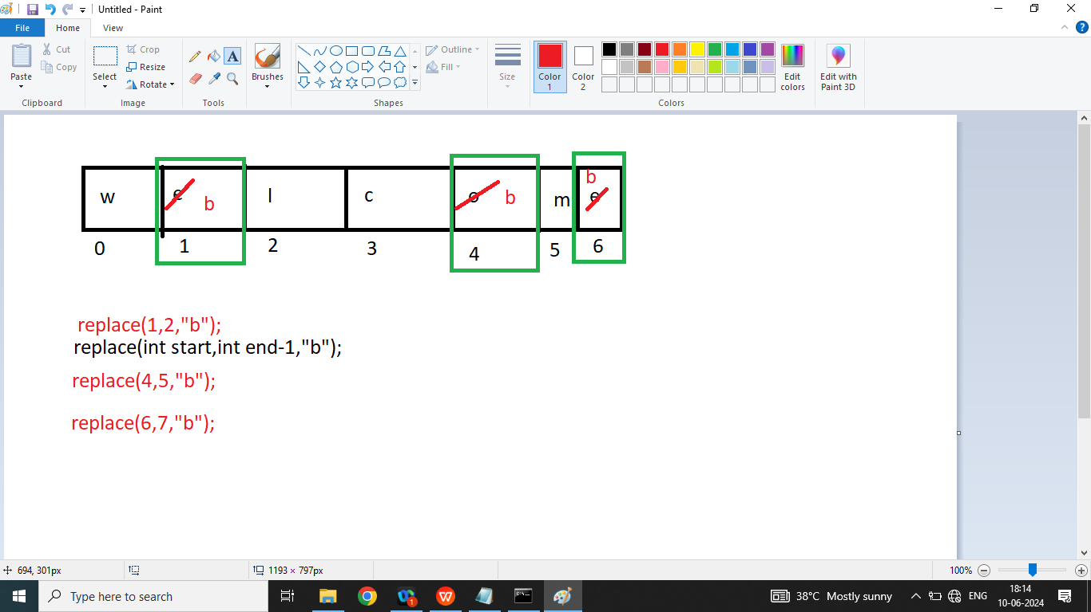

Q4.Explain StringBuffer class **delete method** in java programming?

Ans: The delete() method of StringBuffer class deletes the String from fromINdex to EndIndex.

Syntax:

StringBuffer delete(int start,int end);

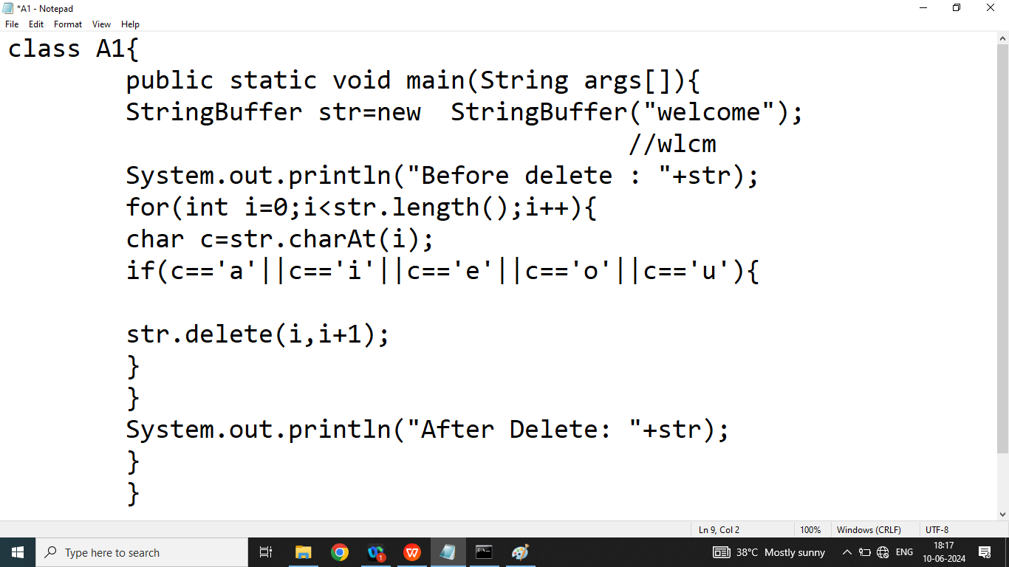

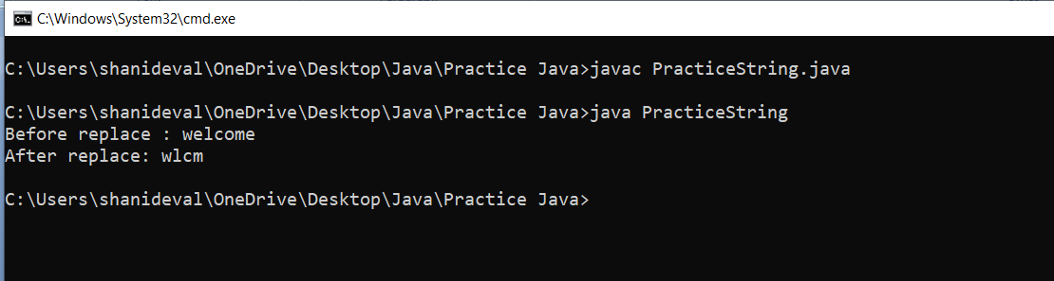

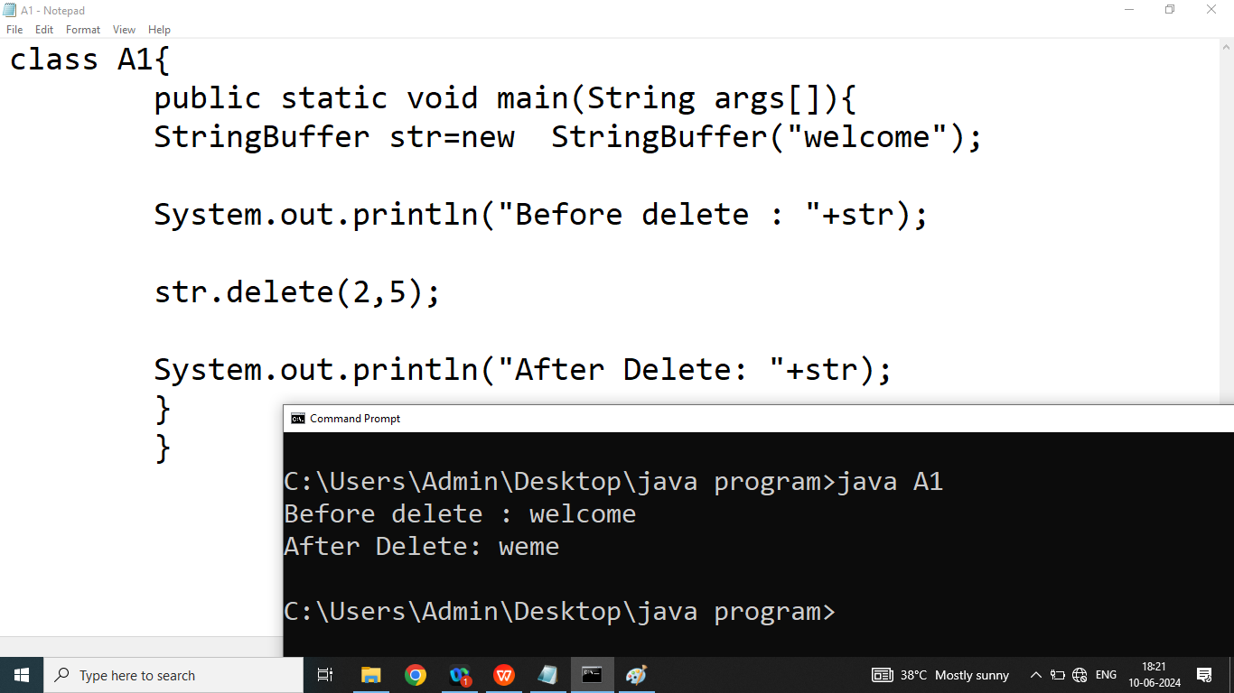

Q5. Explain StringBuffer class **deleteCharAt()** method in java programming?

Ans: It is used to delete single character at a time from the give String.

Syntax:

StringBuffer deleteCharAt(int index);

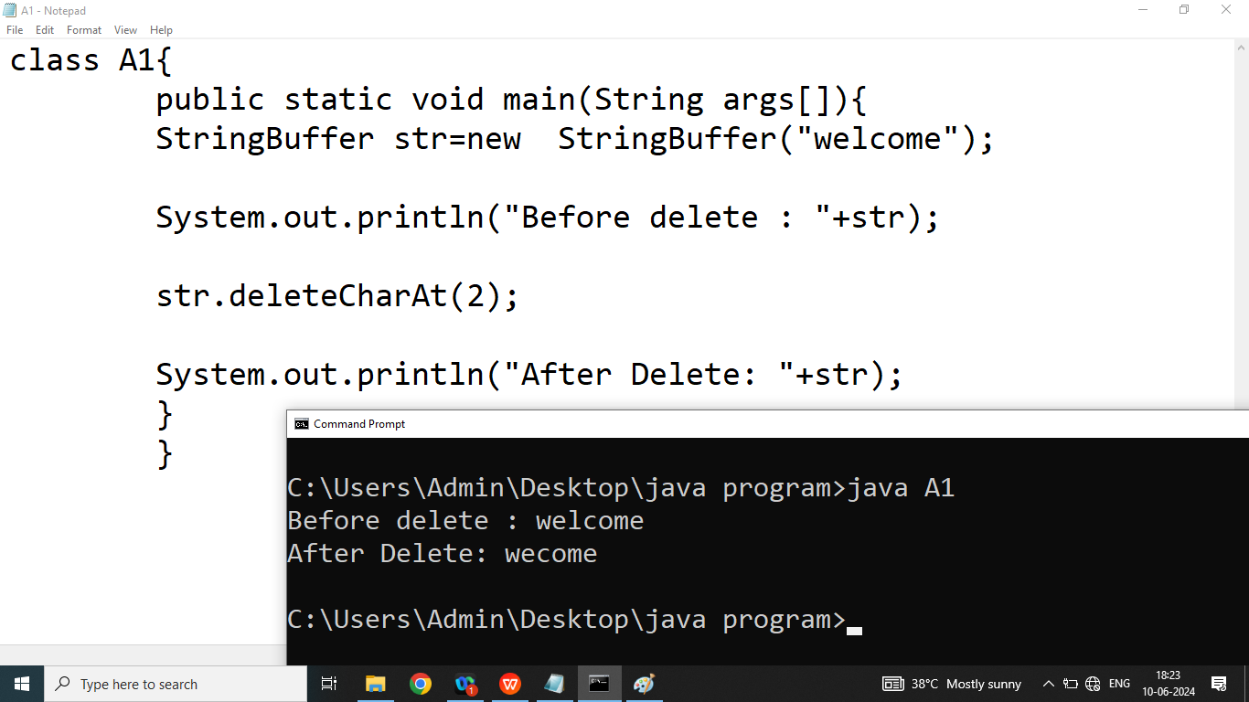

Q6. Explain StringBuffer class **reverse()** method in java programming?

Ans: It is used to reverse the specified String.

Syntax:

StringBuffer reverse()

